|  |
| --- |
|  |
| 新概念 3 册 |
| Lesson32 A lost ship |

Book

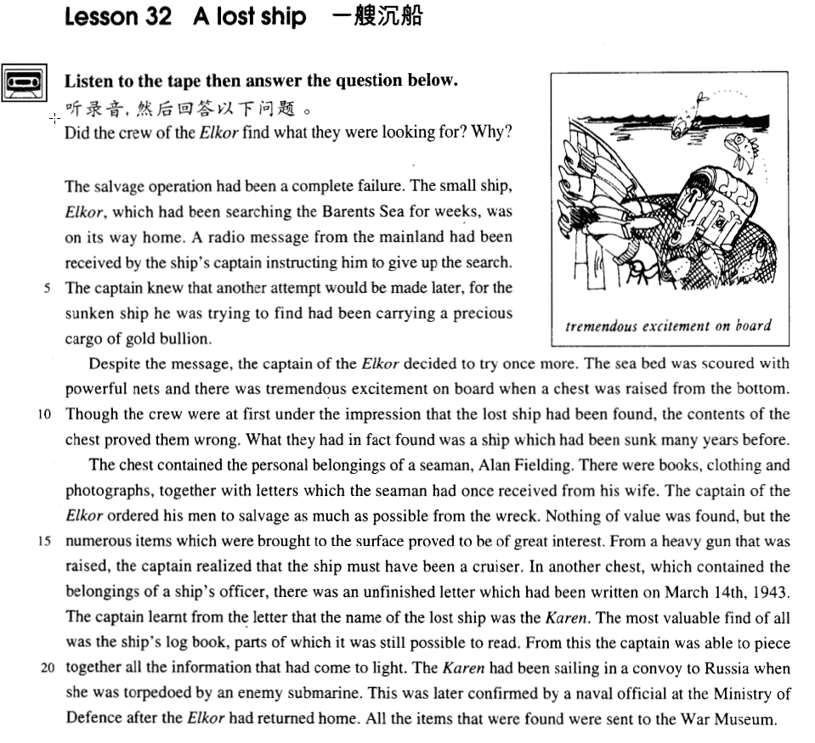

课文

The salvage operation had been a complete failure.

打捞工作彻底失败了。

The small ship, Elkor, which had been searching the Barents Sea for weeks, was on its way home.

小船“埃尔科”号在巴伦支海搜寻了几个星期之后，正在返航途中。

A radio message from the mainland had been received by the ship's captain instructing him to give up the search.

返航前，该船船长收到了大陆发来的电报，指示他们放弃这次搜寻。

The captain knew that another attempt would be made later, for the sunken ship he was trying to find had been carrying a precious cargo of gold bullion.

船长知道日后还会再作尝试，因为他试图寻找的沉船上载有一批珍贵的金条。

Despite the message, the captain of the Elkor decided to try once more.

尽管船长接了电报，他还是决定再试一试。

The sea bed was scoured with powerful nets and there was tremendous excitement on board when a chest was raised from the bottom.

他们用结实的网把海床搜索了一遍。当一只箱子从海底被打捞上来时，甲板上人们激动不已。

Though the crew were at first under the impression that the lost ship had been found, the contents of the chest proved them wrong.

船员们开始认为沉船找着了，但海底沉箱内的物品证明他们弄错了。

What they had in fact found was a ship which had been sunk many years before.

事实上，他们发现的是另一艘沉没多年的船。

The chest contained the personal belongings of a seaman, Alan Fielding.

木箱内装有水手艾伦.菲尔丁的私人财物，

There were books, clothing and photographs, together with letters which the seaman had once received from his wife.

其中有书箱、衣服、照片以及水手收到的妻子的来信。

The captain of the Elkor ordered his men to salvage as much as possible from the wreck.

“埃尔科”号船长命令船员们尽量从沉船中打捞物品，

Nothing of value was found, but the numerous items which were brought to the surface proved to be of great interest.

但没发现什么值钱的东西，不过打捞出来的众多的物品还是引起了大家极大的兴趣。

From a heavy gun that was raised, the captain realized that the ship must have been a cruiser.

从捞起的一门大炮来看，船长认为那艘船一定是艘巡洋舰。

In another chest which contained the belongings of a ship's officer, there was an unfinished letter which had been written on March 14th, 1943.

另一只海底沉箱中装的是船上一位军官的财物，其中有一封写于1943年3月14日的信，但没有写完。

The captain learnt from the letter that the name of the lost ship was the Karen.

从这封信中船长了解到沉船船名是“卡伦”号。

The most valuable find of all was the ship's log book, parts of which it was still possible to read.

打捞到的东西中最有价值的是船上的航海日志，其中有一部分仍然清晰可读。

From this the captain was able to piece together all the information that had come to light.

据此，船长可以将所有的那些已经搞清的材料拼凑起来。

The Karen had been sailing in a convoy to Russia when she was torpedoed by an enemy submarine.

“卡伦”号当年在为其他船只护航驶往俄国的途中突然遭到敌方潜水艇鱼雷的袭击。

This was later confirmed by a naval official at the Ministry of Defence after the Elkor had returned home.

这一说法在“埃尔科”号返航后得到的国防部一位海军官员的证实。

All the items that were found were sent to the War Museum.

那次打捞到的所有物品均被送往军事博物馆。

词汇讲解

* **salvage** ['sælvɪdʒ] v. 营救，拯救，打捞 （一般救物资，不救人）(lesson7)

**salvage …from …** 从…救…

* He tried desperately to **salvage** belongings **from** the burning house.

**save / rescue** 救，（人和事物都可以）

* When you **rescued** your trousers, did you find the note was whiter than white?
* When a passing tanker **rescued** them five days later, both men were genuinely sorry that they had to leave.

**pick sb. up** 把（被困的人）救上来

* The 'Antoinette' floated on the water until Latham was **picked up** by a ship.
* **sunken** ['sʌŋkən] adj. 沉没的，（只能做定语，修饰名词；不能做表语）
* **sunken** treasure 沉入水中的宝藏
* a **sunken** ship
* ~~The ship was sunken.~~ X错误，不能做表语
* The ship has **sunk** / has been **sunk**. √ （原型sink）

her **sunken** eyes / cheeks 深陷的研究/脸颊

**unsinkable *adj.*** 不会下沉的，不会沉底的

* At that time, however, she was not only the largest ship that had ever been built, but was regarded as **unsinkable**, for she had 16 watertight compartments.
* **scour** ['skaʊə(r)] v. 彻底搜索

**search (a place) for ..**. 搜寻某个东西

* The detective is **searching for** clues.
* The small ship, Elkor, which had been **searching** the Barents Sea for weeks, was on its way home.

**hunt for ...** 到处搜寻或寻找

* I’m **hunting for** a job now.
* The **hunt for** the puma began in a small village where a woman picking blackberries saw 'a large cat' only five yards away from her.

**fumble for ...** 摸索着寻找…

* She **fumbled for** her keys in her purse.
* If you are lucky enough to get a sleeper, you spend half the night staring at the small blue light in the ceiling, or **fumbling** to find your ticket for inspection.

**scour a place for ...**在某地地方彻底搜索

* The sea bed was **scoured with** powerful nets ...

**comb a place for ...** 在某地地方彻底搜索

* The police are **combing the woods for** the fugitive.
* **chest** [tʃest] n. 大箱子（装贵重物品）

**chest** 装贵重物品的箱子

**cardboard box** 纸板箱

**packing case** 运输物品的木箱

**suitcase** 行李箱

**boot / trunk** (汽车的)后备箱

**money box / piggy bank** 存钱罐

* **belongings** [bɪ'lɒŋɪŋz] n. 财产，动产，所有物（动产）

**belongings / things** （习惯用复数）动产

* He told me to unpack my **things** and then come down to dinner.

**property / real estate** 不动产/房地产

* the property market 房地产市场
* real estate agent 房地产经纪人

**possessions / property** 泛指财产（动产不动产都可）

* People tend to amass **possessions**, sometimes without being aware of doing so.

**assets** 资产

* liquid / fixed / tangible / intangible assets 流动/固定/有型/无形资产
* **cruiser** ['kru:zə(r)] n. 巡洋舰

【词根】“**cru**” = **cross**

【同根词】

**cruise** ***n.*** 巡航，巡游

**crucial** ***adj.*** 重要的；决定性的；定局的；决断的

**crusade** ***n.*** 改革运动；十字军东侵; 圣战

* a **crusade** against official corruption
* **find** [faɪnd] n. 被找到的人或物 (褒义，一般强调被发现的有价值的人或事务)
* My new secretary is a real **find**.
* I made a great **find** in a second-hand bookstore.

**buy / bargain** n. 便宜货

* **走遍美国**
* Oh my! Here’s a real **buy**. It’s a bargain. This house just came on the market.

**must** ***n.*** 绝对必要的事物

* **托福听力真题：**

A．Move to a cheaper apartment.

B．Find a person to share their apartment.

C．Hire a new worker.

D．Write an accurate description of a friend.

* W1: What we need is a roommate who is neat and considerate.
* W2: Let’s write that in the ad: neat-ness and consideration a **must**.
* What do the speakers hope to do?
* Answer: (B) Find a person to share their apartment.
* **naval** ['neɪvl] adj. 海军的

**navy** 海军

**land force** 陆军

**air force** 空军

【词根】**nav / nau** = **ship**

【同根词】

**navigation** ***n.*** 航行；航海

**nausea** ***n.*** 恶心，晕船；极端的憎恶

**nauseate** ***vi.*** 作呕；厌恶；产生恶感 ***vt.*** 使厌恶；使恶心；使作呕

**nautical** ***adj.*** 航海的，海上的；船员的

**nautical chart**  ***un.*** 航海图

**nautical mile** ***adj.*** 海里 ***n.*** 海里（合 1852 米）

**aeronautics** ***n.*** 航空学；飞行术

**astronautics** ***n.*** 航天学；宇宙航行

* Beijing University of **Aeronautics** and **Astronautics**

课文讲解

# （第一段）

# The salvage operation had been a complete failure.

知识点（1）

**operation**: work / activity / action 工作/活动/行动

* rescue / relief / cleanup **operation** 营救/缓解/清洁**行动**
* For them this is a major **operation** which involves considerable planning.

**operation** 手术

* The patient will **have / undergo** an **operation on** appendicitis.
* The doctor will **do / perform / carry out** an **operation on** the patient for appendicitis.
* He is an authority on **surgery**（泛指外科手术）.

知识点（2）

课文写法替换：

* The salvage operation **had proved (to be)** a complete failure. **被证明是…**
* The salvage operation had been a (complete) **fiasco**.
* The salvage operation had been in **vain**.

# The small ship, Elkor, which had been searching the Barents Sea for weeks, was on its way home.

**语法分析：**

The small ship, Elkor（同位语）, which had been searching the Barents Sea for weeks（时间状语） （which引导非限定性定语从句）was on its way home.

知识点（1）

语法：“船”做同位语时，定冠词可省略

* The loss of **the Titanic**
* The great ship, **Titanic**, sailed for New York from Southampton on April 10th, 1912.
* The Cutty Sark
* One of the most famous sailing ships of the nineteenth century, **the Cutty Sark**, can still be seen at Greenwich.

知识点（2）

**语法**：定语从句充当状语从句，简化句子。前面相邻的词或短语必须是下面句子的一个成分

* 课文时间状语写法：
* The small ship, Elkor, ***after she***had been searching the Barents Sea for weeks, was on its way home.
* I have to be very careful not to offend the boss, **who**（充当原因状语） could fire me at any time.
* I have to be very careful not to offend the boss, ***because he***could fire me at any time.
* The action, **which** （充当让步状语）has aroused universal disapproval, is nevertheless the only solution.
* The action, ***although it*** has aroused universal disapproval, is nevertheless the only solution.

知识点（3）

**on one’s way (to …)** 在…的路上

* **On his way to the sweet shop**, he dropped his fifty pence and it bounced along the pavement and then disappeared down a drain.
* **造句**：在 Ellesmere 公司工作的垃圾工 Alfred Bloggs，在连续工作了 8 小时之后，正在回家的途中。
* … Alfred Bloggs who worked as a dustman **for** the Ellesmere Corporation.
* Some plays are so successful that they run for years **on end**.

模仿新概念的课文完成上面造句

* Alfred Bloggs, a dustman **for** the Ellesmere Corporation, who had been working **for** 8 hours on end, was on his way home.

# A radio message from the mainland had been received by the ship's captain instructing him to give up the search.

**语法分析：**

A radio message *from the mainland（介词短语当后置定语）* had been received by the ship's captain instructing him to give up the search（后置定语,修饰radio message）.

知识点（1）

表达“**电报**”：

**radio message**

**radiogram**

**telegram**

知识点（2）

**mainland** 大陆

**mainland** Europe （名字做定语）

**mainland** China

知识点（3）

表达“**船上的人**”：

**captain / skipper** 船长

**first mate**  大副

**sailor / seaman / mariner** 船员、水手

**crew** 全体船员（可数）

* She was carrying 1,316 passengers and a **crew** of 89l.
* Though the **crew** were at first under the impression that …

知识点（4） lessson5

**instruct sb. to do ...**（正式的）命令某人做某事

* The editor at once sent the journalist a fax **instructing him to find** out the exact number of steps and the height of the wall.
* Mrs. Ramsay was **instructed to place** the money in a cardboard box and to leave it outside her door.

知识点（5）

表达“**放弃**”：

**give up** the search

**abandon** the search

**stop / cease** the search

**abort** the search

* **造句**：老太太收到绑匪的一封信，命令她支付 1,000 英镑的赎金。
* A letter from the kidnappers had been received by the old lady instructing her to pay a ransom of ￡1,000.
* **造句**：考古学家作出了一个有趣的发现，一尊古代的女神像原来竟是 (turn out to be) 一位看上去很摩登的女郎 (a very modern-looking woman)。
* An interesting discovery was made by archeologists that an ancient statue of a goddess turned out to be a very modern-looking woman.

# The captain knew that another attempt would be made later, for the sunken ship he was trying to find had been carrying a precious cargo of gold bullion.

**语法分析：**

The captain knew that another attempt would be made later（宾语从句）, for the sunken ship *he was trying to find（定语从句）* had been carrying a precious cargo of gold bullion. （for后面引导原因状语从句)

知识点（1）

**make an attempt to do ..**. 常识做某事

* The captain knew that his attempt would not be the only attempt. （不简洁）
* The captain knew that his （形容词性物主代词，修饰别的名词）attempt would not be the only **one**.
* The captain knew that his （名词性物主代词）would not be the only attempt. **（高级表达）**
* **课后题：**

4．The captain knew that ___B___ the only attempt. (1.5)

(a) it was not

(b) his had not been

(c) **his would not be**

(d) it had not been

**简洁表达举例：**

* Our age is a tragic age. （不简洁）
* Our age is a tragic one. （不简洁）
* **Ours is a tragic age.** — Shakespeare （简洁）

***Brevity is beauty.*** 简洁即是美。

知识点（2）

**cargo** [C]（船或飞机装载的）货物

**freight** [U]（海运、空运或陆运的）货物；货运

* The ship carries both **freight** and passengers.

**cargo ship / airplane** 货轮/机

**freight train** 货车

知识点（3）

gold bullion 纯金

# （第二段）

# Despite the message, the captain of the Elkor decided to try once more.

# The sea bed was scoured with powerful nets and there was tremendous excitement on board when a chest was raised from the bottom.

**语法分析：**

The sea bed was scoured with powerful nets and there was tremendous excitement on board *when a chest was raised from the bottom（时间状语从句）*.

知识点（1）

**sea bed / sea floor / sea bottom** 海床

知识点（2）

**tremendous** adj. very great

* In his day, Mendoza enjoyed **tremendous** popularity.
* Though the new rudder was fitted at **tremendous** speed, it was impossible for the Cutty Sark to win.
* The response to this competition was **tremendous**.

知识点（3）

**on board / aboard** 在船上

* **老友记**
* All ticketed passengers for Flight 1066 to Athens should now be **on board**.
* I get it!
* **老友记**
* I’m so excited about having Monica come **on board with us**.
* **走遍美国**
* His experience will be valuable to both of us. **Welcome aboard**（习语）, Malcolm!

知识点（4）

* … here was tremendous excitement on board **地道表达**
* ... people on aboard were very excited ... 不地道
* **造句**：消息传来时，演播室 (studio) 里的人们非常激动。
* There was tremendous excitement in the studio when the news came. **地道表达**
* **造句**：有越来越多的人对英语有兴趣。
* There are more and more people who are interested in English. 不地道
* There is growing interest in English. **地道表达**
* **造句**：人们普遍同意妇女应该享有和男人完全的平等。
* People generally agree that women should enjoy full equality with men. 不地道
* There is general agreement that women should enjoy full equality with men. **地道表达**

# Though the crew were at first under the impression that the lost ship had been found, the contents of the chest proved them wrong.

**语法分析：**

Though the crew were at first under the impression that the lost ship had been found（做the impression的同位语从句） （Though引导让步状语从句）, the contents of the chest proved them（宾语） *wrong（宾语补足语）*.

知识点（1）

**be under the impression that ...** 还以为

* Sorry, I **was under the impression that** you were the manager.

give sb. the impression that ... 使某人认为、觉得

* The sudden movement of the door made it sway slightly and it **gave me the impression that** it was about to leap out at me.

**be /live under the illusion / delusion that ...** 误以为

* Even he still **lives under the illusion that** country life is somehow superior to town life.
* The worst thing about the do-it-yourself game is that sometimes even men **live under the delusion that** they can do anything, even when they have repeatedly been proved wrong.

知识点（1）

**prove + 宾语 + 宾补**

* The facts **proved** **their worries** **unnecessary**.

# What they had in fact found was a ship which had been sunk many years before.

**语法分析：**

What they had in fact found（主语从句） was a ship *which had been sunk many years before（定语从句，修饰ship）.*

* **造句**：哥伦布其实发现的不是印度，而是一个全新的大陆，在那里土著居民 (aborigine) 已经居住了 (inhabit) 两万多年了。
* What Columbus had in fact found was not India but a new continent which had been inhabited by aborigines for over twenty thousand years.

# （第三段）

# The chest contained the personal belongings of a seaman, Alan Fielding.

# There were books, clothing and photographs, together with letters which the seaman had once received from his wife.

**语法分析：**

There were books, clothing and photographs, together with letters which the seaman had once received from his wife（定语从句，修饰letters） (together with后伴随状语).

知识点（1）

**clothing** **[U]** 衣服；（尤指某种）服装

**clothes** **[pl.]** 衣服；服装

* Fine **clothes** make a man.
* Food, **clothing**, shelter and transportation are daily necessities.

知识点（1）

**together with …** 还有

= **along with …**

* Peter was murdered, **together / along with** three guards.
* These new facts, **together / along with** the other evidence, prove the prisoner's innocence.

# The captain of the Elkor ordered his men to salvage as much as possible from the wreck.

知识点（1）

**one’s man** （军队）手下的士兵

* **his men**
* The general ordered **his men** to fire.
* In times of peace, when business was bad, Hawkwood and **his men** would march into a city-state and, …

**subordinate** 下级；部属

* He left the routine check to one of his subordinates.

**superior** 级别（或地位、职位）更高的人；上级；上司

* I’ll pass your complaint on to my superiors.

**counterpart** 职位（或作用）相当的人；对应的事物

* President Cai and his American counterpart Barack Obama will hold talks on Monday.

**the grassroots** （某个组织）地位最低的人

知识点（2）

**shipwreck** 失事的船；沉船

**wreck** （事故中）遭严重毁坏的汽车（或飞机等）；身体或精神上）受到严重损伤的人

* Poor man! — mentally a **wreck**.

# Nothing of value was found, but the numerous items which were brought to the surface proved to be of great interest.

**语法分析：**

Nothing *of value（介词短语当后置定语，修饰nothing）* was found, but the numerous items which were brought to the surface（定语从句，修饰items） proved to be *of great interest*.

知识点（1）

**语法**：**of + 名词** : 描述人或事物的特征

1、做后置定语。

* nothing **of** value = nothing valuable
* a matter **of** significance = a significant matter
* a ship **of** 46,000 tons
* a man **of** wide social relations

2、在系动词后做表语。

* ... proved to be **of** **great interest**. = proved to be **very interesting**.
* It is **of** no use = it is useless.
* Her dress is **of** dark crimson.
* He is **of** a peculiar disposition.
* a man **of middle height** = The man is of middle height.
* a girl **of remarkable imagination** = The girl is of remarkable imagination.

知识点（2）

**numerous** （修饰可数名词）众多的；许多的

= **countless**

* There are **countless** people who, ever since their early years, have learned to associate snails with food.

# From a heavy gun that was raised, the captain realized that the ship must have been a cruiser.

**语法分析：**

From a heavy gun that was raised（定语从句，修饰gun）（介词短语当状语）, the captain realized *that the ship must have been a cruiser.* （宾语从句）

知识点（1）

**from** prep. 考虑到，从……来看/判断

* **From** *her looks* I'd say she was Swedish.
* **From** *what I heard* the company's in deep trouble.
* **From** *this* the captain was able to piece together all the information that had come to light.
* 造句：从这些雕像的碎片来看，考古学家们明白了这座庙宇当初肯定是一个祭祀的场所。
* **From** the fragments of statues, the archaeologists realized that the temple must have been a place of worship.

# In another chest which contained the belongings of a ship's officer, there was an unfinished letter which had been written on March 14th, 1943.

**语法分析：**

In another chest（地点状语), which contained the belongings of a ship's officer（定语从句，修饰chest）, there was an unfinished letter *which had been written on March 14th, 1943（定语从句，修饰letter）*.

知识点（1）

课文写法替换：

**date** 标注日期

* ... which **was dated** March 14th, 1943.

相似举例，过去分词做后置定语：

* a newspaper **dated** October 1st, 2005
* a girl **aged** 20
* a man **named** John
* a novel **entitled** Three Kingdoms
* a movie **starring**（主动结构） Tom Hanks
* The movie **starred** Tom Hanks

# The captain learnt from the letter that the name of the lost ship was the Karen.

**语法分析：**

The captain learnt *from the letter（状语前置) that the name of the lost ship was the Karen.* *（宾语从句）*

# The most valuable find of all was the ship's log book, parts of which it was still possible to read.

**语法分析：**

The most valuable find of all was the ship's log book, *parts of which（引导非限定性定语从句，做to read的宾语）* *it（形式主语） was still possible to read（真正主语）.*

知识点（1）

**语法：**“名词 + 介词 + 关系代词” 引导**非限定性定语从句**；前提是定语从句修饰的不是先行词本身，而是先行词相关的东西或一部分

* **造句**：他有两个儿子，其中的一个死于战火。
* He has two sons, **one of whom** died in the war.
* **造句**：演讲者提了 (pose) 四个问题，它们的答案被证明非常具有启发性(illuminating)。
* The speaker posed four questions, **the answers to which** proved very illuminating.

知识点（2）

**课文写法替换：**

* …, parts of which it was still possible *to read*.
* ..., parts of which were still possible *to read*. **（形容词后加动词不定式，主动表被动的含义）**

**扩展：**

* Most of our fears are unreasonable, but they are impossible *to erase*.
* Most of our fears are unreasonable, but it is impossible *to erase them*. **（主动形式）**

**possible 和 impossible 主语不能是人**

* …, but it was impossible to stop the thieves. √
* ~~…, but the thieves were impossible~~ *~~to stop~~*~~. X 错误~~
* He is impossible *to deal* ***with***. √（主语相当于做的是介词宾语）

**课文写法替换：**

* ..., parts of which **could still be read**.
* ..., parts of which **were still legible**.

# From this the captain was able to piece together all the information that had come to light.

**语法分析：**

From this（介词短语当状语）the captain was able to piece together *all the information that had come to light（定语从句，修饰information） （all后面做piece的宾语）.*

知识点（1）

**piece sth. ↔ together** 把…拼凑起来，以发现事情的原貌；（together位置灵活）

* The police are still trying to **piece together the facts**.
* The archaeologists **pieced the fragments together**.

**reconstruct**

* When the archaeologists **reconstructed** the fragments, they were amazed to find that the goddess turned out to be a very modern-looking woman.

知识点（2）

**come to light / be brought to light** 被发现

* New evidence in this case has recently **come to light**.
* New evidence in this case has recently **been brought to light**.

**cast / shed / throw light on ...** 揭示了…

* These discoveries may **cast** some **light on** the origins of the universe.
* Even seemingly insignificant remains can **shed** interesting **light on** the history of early man.

# The Karen had been sailing in a convoy to Russia when she was torpedoed by an enemy submarine.

**语法分析：**

The Karen had been sailing（过去完成进行时） in a convoy to Russia when（“这时”） she was torpedoed by an enemy submarine（时间状语从句）.

知识点（1）

**语法复习：**主句（**进行时** / **be about to do**）+ when ... “when”应译为**“这时”**或**“突然”**

* I ***was having***dinner **when** the phone rang.
* I ***was about to leave*****when** the phone rang.
* **课后题**：Lesson 15
* 6．He ___D___ to the sweet shop when he dropped his fifty pence. (11.10-1 1)

(a) had gone (b) was going to go ‘(c) went (d) was going

* He ***was going***to the sweet shop **when** he dropped his fifty pence.
* He ***was***still ***mumbling***something about hospitals at the end of the party **when** he slipped on a piece of ice and broke his left leg.
* The idea never appealed to me very much, but one day, after a heavy shower, I happened to ***be walking***in my garden when I noticed a huge number of snails taking a stroll on some of my prize plants.
* The morning passed rapidly and Frank ***was about to leave*****when** he noticed a large packing case lying on the floor.

# This was later confirmed by a naval official at the Ministry of Defence after the Elkor had returned home.

**语法分析：**

This was later confirmed by *a naval official at the Ministry of Defence（介词短语当后置定语，修饰official）* after the Elkor had returned home（时间状语）.

# All the items that were found were sent to the War Museum.

**语法分析：**

All the items *that were found（定语从句，修饰items）* were sent to the War Museum.